7. Design a VB application to record the employee details such as EmpId, EmpName, Designation and BaiscPay. Calculate the DA, HRA, Deduction and Gross Salary.(Make the necessary assumptions )Use Select .. case for decision making.

Dim da As Double, hra As Double, pf As Double, gr As Double, bs As Double

Private Sub Command1_Click()

bs = Val(Text4.Text)

Select Case bs

Case Is >= 50000

da = bs * 20 / 100

hra = bs * 10 / 100

pf = bs * 12 / 100

Case Is >= 25000

da = bs * 15 / 100

hra = bs * 8 / 100

pf = bs * 10 / 100

Case Else

da = bs * 10 / 100

hra = bs * 5 / 100

pf = bs * 8 / 100

End Select

Text5.Text = da

Text6.Text = hra

Text7.Text = pf

Text8.Text = bs + da + hra - pf

End Sub

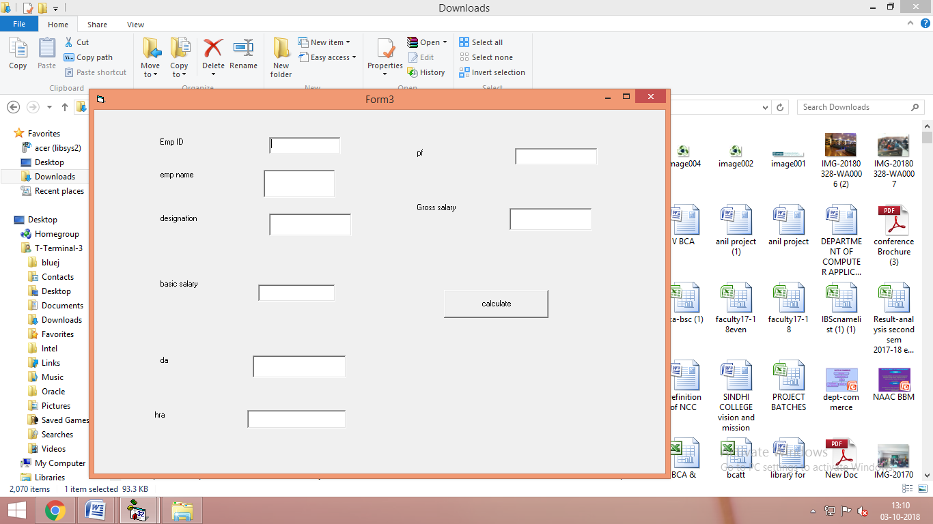

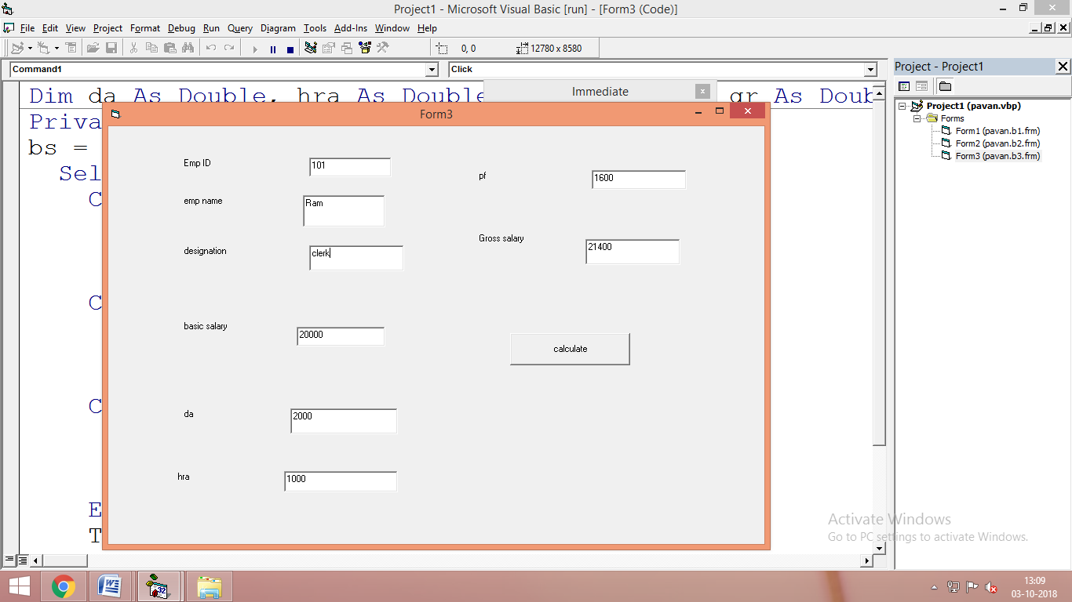\

1. VB program to calculate the simple interest and compound interest. Use DLLs for the calculation.

Main Program

Dim obj As New Class1

Dim p As Double, t As Double, r As Double

Dim si As Double, ci As Double

Private Sub Form_Load()

Set obj = New Class1

End Sub

Private Sub Command1_Click()

p = Val(Text1.Text)

t = Val(Text2.Text)

r = Val(Text3.Text)

si = obj.simpleint(p, t, r)

Text4.Text = si

End Sub

Private Sub Command2_Click()

p = Val(Text1.Text)

t = Val(Text2.Text)

r = Val(Text3.Text)

ci = obj.compoundint(p, t, r)

Text5.Text = ci

End Sub

Class module

Dim si As Double, ci As Double

Public Function simpleint(a As Double, b As Double, c As Double)

simpleint = a * b * (c / 100)

End Function

Public Function compoundint(a As Double, b As Double, c As Double)

Dim d As Double

d = a * (1 + c / 100) ^ b

compoundint = d - a

End Function

